SCHOOL

Trial WACE Examination, 2010

Question/Answer Booklet

MATHEMATICS
SOLUTIONS

2C/2D(2)

Section Two:

Calculator-assumed

Student Number: In figures

In words

Your name

Time allowed for this section
Reading time before commencing work: 10 minutes
Working time for paper: 100 minutes

Material required/recommended for this section

To be provided by the supervisor
This Question/Answer booklet
Formula sheet (retained from Section One)

To be provided by the candidate
Standard items: pens, pencils, pencil sharpener, eraser, correction fluid, ruler, highlighters

Special items: drawing instruments, templates, notes on two unfolded sheets of A4 paper, and up to three calculators satisfying the conditions set by the Curriculum Council for this course.

Important note to candidates

No other items may be used in this section of the examination. It is your responsibility to ensure that you do not have any unauthorised notes or other items of a non-personal nature in the examination room. If you have any unauthorised material with you, hand it to the supervisor before reading any further.

Structure of this paper

Section | Number of questions available | Number of questions to be answered | Working time (minutes) | Marks available
Section One:  Calculator-free | 7 | 7 | 50 | 40
Section Two:  Calculator-assumed | 11 | 11 | 100 | 80
 |  |  |  | 120

Instructions to candidates

- The rules for the conduct of Western Australian external examinations are detailed in the Year 12 Information Handbook 2010. Sitting this examination implies that you agree to abide by these rules.

- Write your answers in the spaces provided in this Question/Answer Booklet. Spare pages are included at the end of this booklet. They can be used for planning your responses and/or as additional space if required to continue an answer.
- Planning: If you use the spare pages for planning, indicate this clearly at the top of the page.
- Continuing an answer: If you need to use the space to continue an answer, indicate in the original answer space where the answer is continued, i.e. give the page number. Fill in the number of the question(s) that you are continuing to answer at the top of the page.

- Show all your working clearly. Your working should be in sufficient detail to allow your answers to be checked readily and for marks to be awarded for reasoning. Incorrect answers given without supporting reasoning cannot be allocated any marks. For any question or part question worth more than two marks, valid working or justification is required to receive full marks. If you repeat an answer to any question, ensure that you cancel the answer you do not wish to have marked.

- It is recommended that you do not use pencil except in diagrams.

Section Two: Calculator-assumed (80 Marks)
This section has eleven (11) questions. Answer all questions. Write your answers in the space provided.

Working time for this section is 100 minutes.

Question 8 (5 marks)
The network shows the roads linking five towns, with the distance between adjacent towns shown on each arc in kilometres.
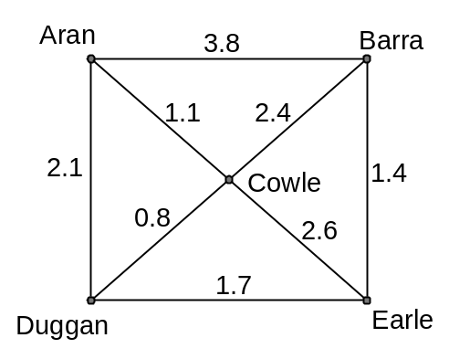

This table shows the shortest distance, in kilometres, to travel from one town to another.

Barra | 3.5
Cowle | 1.1 | 2.4
Duggan | 1.9 | 3.1 | 0.8
Earle | 3.6 | 1.4 | 2.5 | 1.7
 | Aran | Barra | Cowle | Duggan

(a) On the network, the distance between Aran and Barra is shown as 3.8km. In the table, the shortest distance from Aran to Barra is shown as 3.5km. Explain why these figures are different. (1 mark)

The shortest distance from A to B is via C: 1.1+2.4 = 3.5km.
This is less than the direct distance of 3.8km.

(b) Complete the missing 5 entries in the table. (3 marks)

(c) Which roads are never used in calculating the shortest distances in the table? (1 mark)
Aran to Barra (3.8km)
Aran to Duggan (2.1km)
Cowle to Earle (2.6km)

Question 9 (7 marks)
(a) Are the straight lines given by 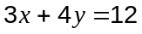 and 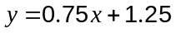 parallel, perpendicular or neither? Justify your answer. (3 marks)
Neither

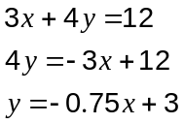

Gradients are not the same (-0.75 and 0.75) so not parallel.

Gradients do not have a product of -1 (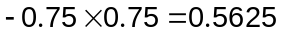) so not perpendicular.

(b) Determine the equation of the straight line perpendicular to the line 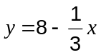 and passing through the point (2, 1). (2 marks)
Required gradient 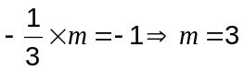.

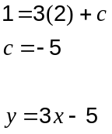

(c) Which of the two points A(-12, 2) and B(8, -9) is furthest from the origin? Justify your answer. (2 marks)
A

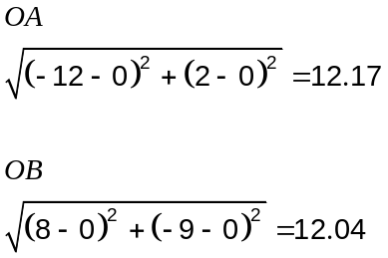

Question 10 (7 marks)
A computer store is offering a new netbook for sale at a cash price of $665.

(a) The store is offering a finance deal based on a 20% deposit followed by 12 monthly payments of $59.75. How much would a customer pay in total for the netbook using this deal? (2 marks)
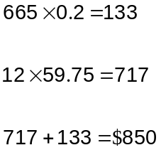

(b) A student borrows the full cash price for 4 months from a lender who charges a flat rate of 13.8%pa. How much do they have to repay the lender, including interest? (2 marks)
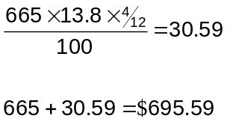

(c) A business buys a new netbook for cash.

(i) What will the value of their netbook be three years later if it is assumed that computers depreciate by 30%pa. (2 marks)
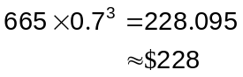

(ii) Sketch a graph of how the value of the netbook changes over three years.
(1 mark)
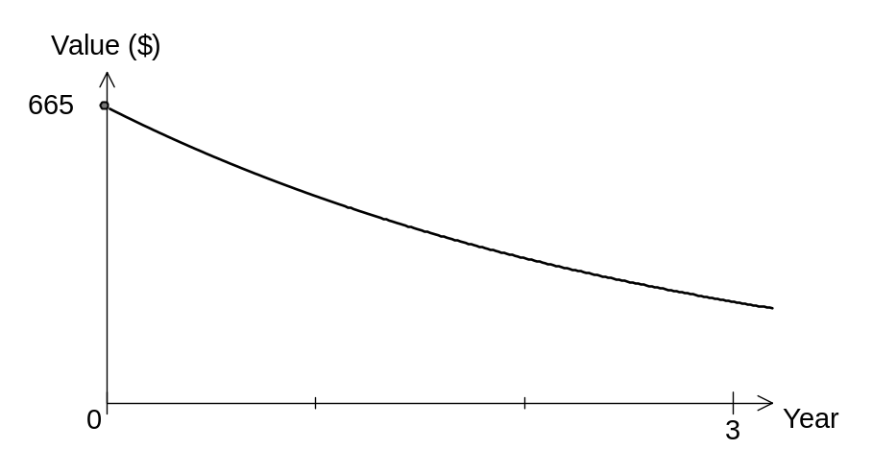

Question 11 (8 marks)
The first and second terms of a sequence are 2 and 6 respectively.

(a) If these terms form part of a geometric sequence

(i) list the next two terms, (1 mark)
18, 54

(ii) state a recursive rule for the sequence. (2 marks)

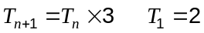

(b) If the two terms form part of an arithmetic sequence, find

(i) the fifth term of the sequence, (1 mark)
Sequence: 2, 6, 10, 14, 18

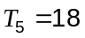

(ii) which term of the sequence is the first to exceed 100. (1 mark)
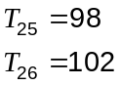

Hence the 26th term.

(c) If the recursive rule for the sequence is given by 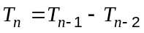, find

(i) 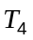, (1 mark)
Sequence: 2, 6, 4, -2

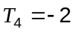

(ii) the smallest value of , 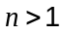, for which 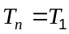. (2 marks)

Sequence: 2, 6, 4, -2, -6, -4, 2, 6, ...

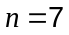

Question 12 (6 marks)
In this diagram, all three vertices of the triangle lie on the circumference of a circle of radius 13cm and the diameter of the circle is the side BC. Side AB is 10cm long and side AC is 24cm.
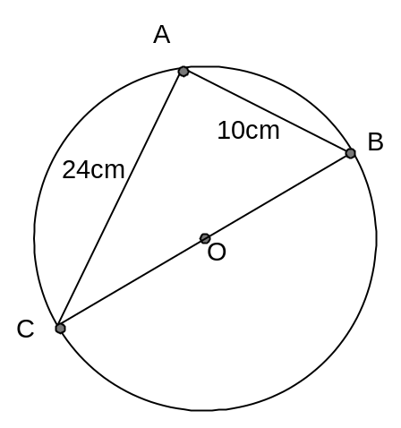

(a) Use the cosine rule to show that the size of angle CAB is 90°. (2 marks)
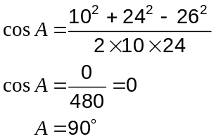

(b) Calculate the size of angle ACB. (2 marks)

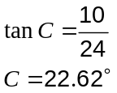

(c) Draw a line from O to A on the diagram above and then find the area of triangle AOC.
(2 marks)
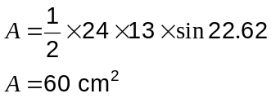

Question 13 (10 marks)
A student was interested in buying either a Holden Barina or Toyota Corolla car. They collected the prices of 8 cars of each type from an internet site, as shown below.

Holden Barina: $7900, $8400, $7800, $6500, $7500, $8400, $7600, $6700.

Toyota Corolla: $9500, $7200, $6100, $6500, $7300, $9700, $6400, $8900.

The mean and standard deviation of the price of the Holden Barinas are $7600 and $656 respectively.

(a) Calculate the mean and standard deviation of the price of the Toyota Corollas. (2 marks)
Mean = $7700

SD = $1359

(b) Calculate the median price for both makes of car. (2 marks)
Barina: $7700

Corolla: $7250

(c) Which is a better measure for comparing average prices for these cars - the mean or median? Explain your answer. (2 marks)
The median as the prices for the Corolla include 3 quite expensive cars, leading to the mean being $450 higher than the median.

(d) Explain why the mode is not a good measure of comparison for these prices. (2 marks)
The mode is suitable for large datasets, but here we only have 8 prices for both. The Corolla does not have a mode and that of the Barina is the most expensive price.

(e) Use statistics from above to explain which car has the larger variation in prices. (1 mark)
The Corolla has a larger variation as its SD is $1359 compared to the smaller $656 for the Barina.

(f) What hidden variables might account for the difference in variation of prices collected by the student? (1 mark)
The Barinas may all be of a similar age or condition, whereas the Corollas might not.

Question 14 (7 marks)
For two subsets A and B taken from a universal set U,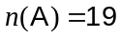, 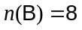, 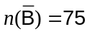 and 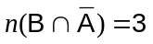.

(a) Draw a Venn diagram to show the above information. (3 marks)
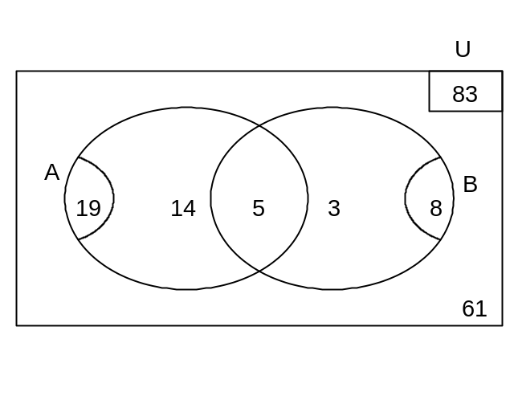

(b) Determine 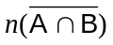. (1 mark)
14+3+61=78

(c) Which is greater, 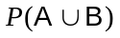 or 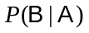? Justify your answer. (3 marks)
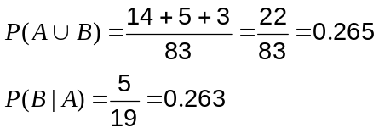

Hence 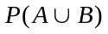 is greater.

Question 15 (10 marks)
A recent study into the annual profitability, in dollars, of individual hospitals owned by a consortium found that it varied with the number of beds,, in each hospital.

Using the model ,

(a) What annual profit is expected if a hospital has 50 beds? (1 mark)
$1 925 000

(b) Graph on the axes below. (3 marks)

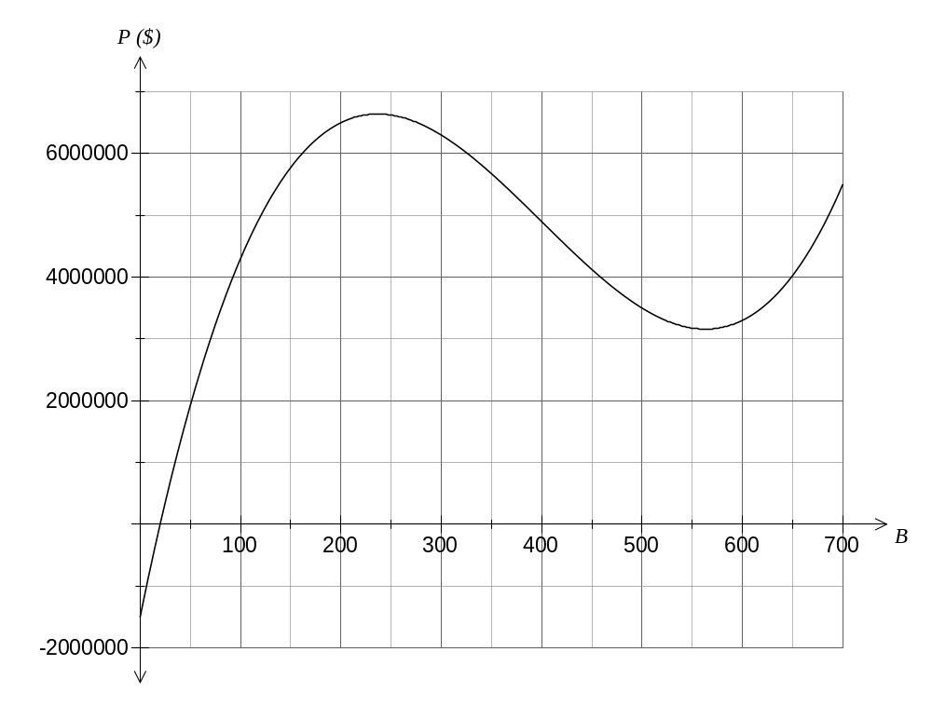

(c) What is the fewest number of beds a hospital needs to make a profit rather than a loss?
(1 mark)
20 beds

(d) A new hospital is being planned for the consortium with between 100 and 400 beds. What number of beds would you recommend and why? (2 marks)

237 beds, as this would return the maximum possible annual profit of approximately $6.64 million.

(e) The consortium are considering closing two smaller hospitals, with 250 and 310 beds, and replacing them with a single hospital to accommodate all their patients. Discuss whether this would be an effective strategy to increase profitability. (3 marks)
P(250) = $6.625m
P(310) = $6.194m

P(560) = $3.159m

This would not be a good strategy as they would be worse off by $9.66 million per year.

The two smaller hospitals currently both make individual profits greater than that of a combined hospital of size 560.

Question 16 (4 marks)
For each of the following conjectures, state whether it is true or false. Give an example or explanation to support each answer.

(a) If a counting number is even then it is not a multiple of 3. (1 mark)

False. 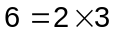

(b) All terms of the sequence 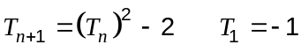 are negative integers. (1 mark)

True. All terms of the sequence are -1.

(c) The mean of three consecutive odd numbers is always odd. (2 marks)
True. The mean will always be the middle one of the three numbers, and since all the numbers are odd, then the mean will be odd.

Question 17 (7 marks)
A class conducted an experiment in which a ball was randomly selected from a bag containing 3 blue balls, 3 yellow, 2 red and a green. The colour of the ball was noted and then it was replaced into the bag. This was repeated a second time and then a tally mark () recorded in the table shown below.

Two balls of the same colour | 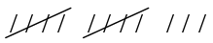
Two balls of different colours

(a) How many times did the class repeat the experiment? (1 mark)
60 times

(b) Based on the above results, what is the probability of drawing two balls of the same colour in this experiment? (1 mark)
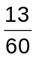

(c) How would changing the number of times the experiment was repeated affect the accuracy of your answer in part (b)? (1 mark)
More experiments would make it more accurate. Fewer experiments would make it less accurate.

Students in the class were then told to simulate the experiment for homework using a sheet of two-digit random numbers, an extract of which is shown here:
39 32 47 64 89 25 59 19 01 18 88 70 43 45 24 40 33 13 98 44 50

Let the digits 1, 2 and 3 represent a blue ball, 4, 5 and 6 represent a yellow ball, 7 and 8 represent a red ball and 9 represent a green ball. Ignore any pair of digits containing a zero.

(d) What balls are represented by first pair of random digits of 39? (1 mark)
A blue (3) and then a green (9), so two balls of a different colour.

(e) How many simulations are possible with the extract? (1 mark)
17

(f) Use the extract of random digits to simulate the experiment and hence estimate the probability of drawing two balls of the same colour. (2 marks)
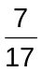

Question 18 (9 marks)
A group of passengers were asked to complete a short questionnaire on boarding their flight. Of the 105 responses

- Half of the 42 passengers who said they were from overseas also said they were on holiday.
- Of the 13 who said they were travelling for other reasons, 7 more came from Australia than overseas.
- 16% of those who said they were on holiday came from Australia.

(a) Complete this table to summarise the above information. (4 marks)

 | Work | Holiday | Other | Total
From Australia | 49 | 4 | 10 | 63
From Overseas | 18 | 21 | 3 | 42
Total | 67 | 25 | 13 | 105
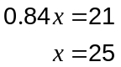

(b) How many passengers were

(i) from Australia and travelling for work purposes? (1 mark)
49

(ii) travelling for holiday purposes or from overseas? (1 mark)
42 + 4 = 46

(c) What is the probability that a randomly chosen passenger from the flight

(i) was travelling for work or holiday reasons? (1 mark)
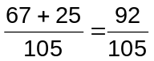

(ii) was not on holiday , if they were from Australia? (2 marks)
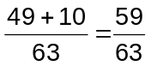

Additional working space

Question number(s):

